**Snowpark API for Python/Scala: Overview and Setup**

**1.1 Introduction to Snowpark**

Snowpark is a developer framework designed to enable data engineers, data scientists, and developers to write data transformation logic in their preferred programming language (Python, Scala, or Java) while leveraging the power and scalability of Snowflake's data cloud. Unlike traditional approaches that require moving data to computation, Snowpark pushes down computations to Snowflake's elastic performance engine.

**1.2 Key Value Propositions**

* **Unified Development Experience**: Write code in familiar languages while executing in Snowflake
* **Performance Optimization**: Automatic query optimization and pushdown of operations
* **Security**: Built-in security features including data encryption and access controls
* **Scalability**: Leverages Snowflake's automatic scaling capabilities
* **Cost Efficiency**: Pay-per-use model with optimized resource utilization

**1.3 Supported Languages and Versions**

| **Language** | **Supported Versions** | **Package Name** |
| --- | --- | --- |
| Python | 3.8, 3.9, 3.10, 3.11 | snowflake-snowpark-python |
| Scala | 2.12, 2.13 | snowflake-snowpark-scala |

**2. System Architecture**

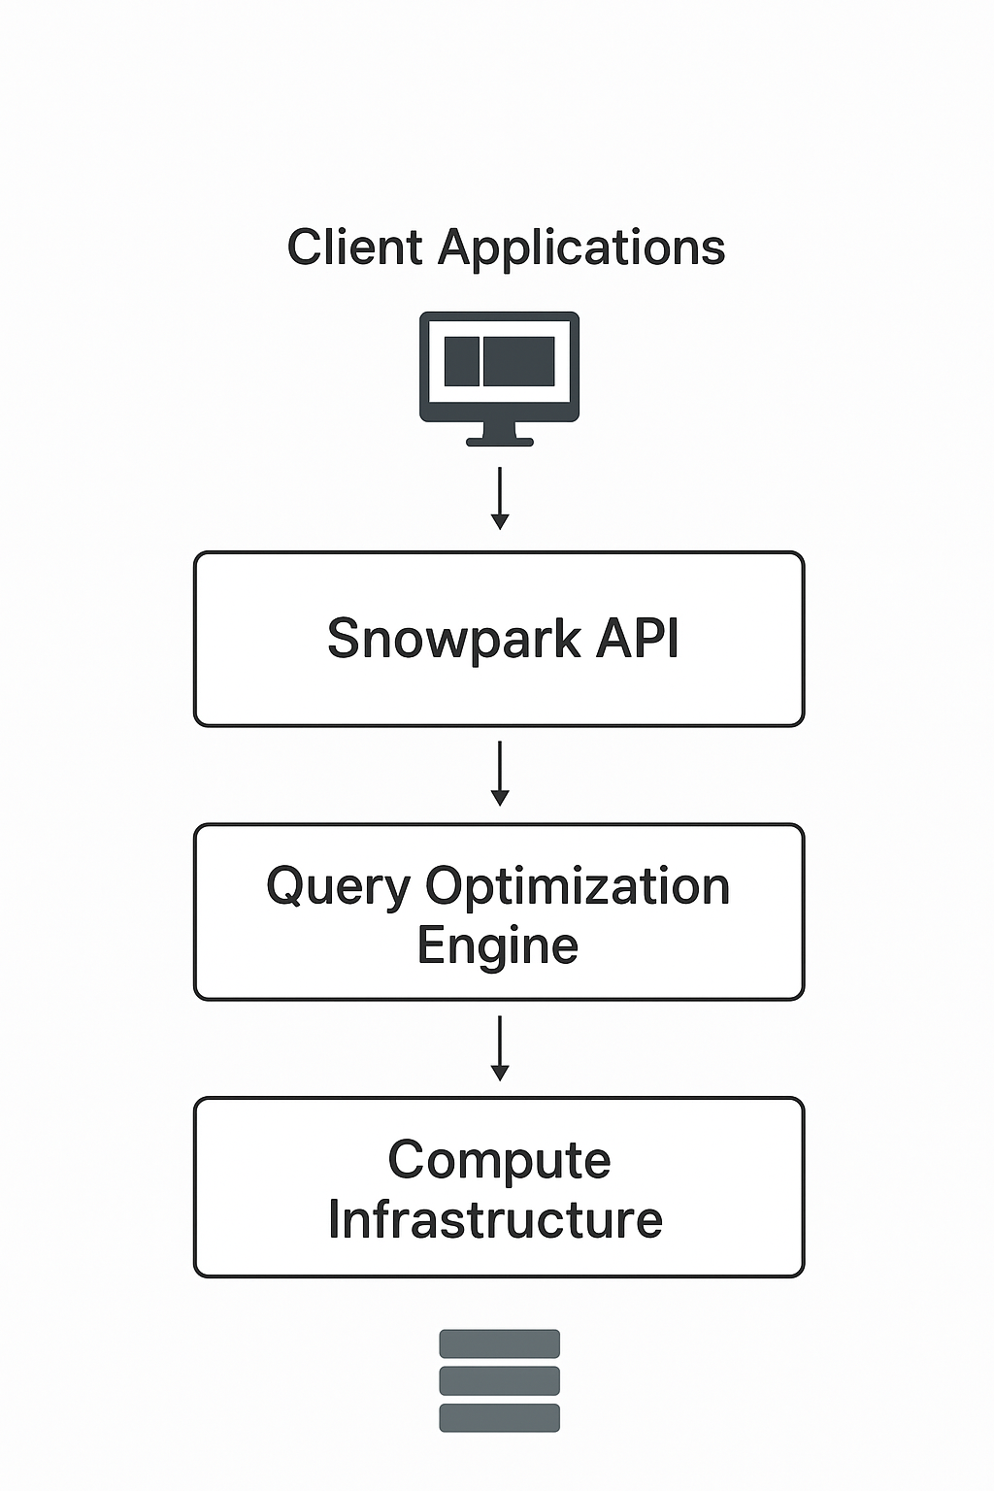

**2.1 High-Level Architecture**

**2.2 Component Architecture**

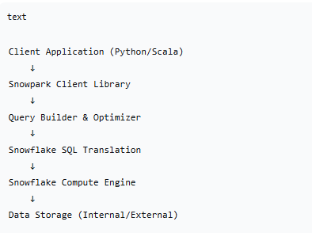

**2.3 Data Flow**

1. **Client Code Execution**: Developer writes transformation logic using Snowpark DataFrames
2. **Lazy Evaluation**: Operations are built as logical plans without immediate execution
3. **Query Optimization**: Snowpark optimizes the logical plan and generates efficient SQL
4. **Pushdown Execution**: SQL is executed in Snowflake's compute engine
5. **Result Retrieval**: Processed results are returned to the client application

**3. Installation and Setup**

**3.1 Prerequisites**

**3.1.1 System Requirements**

* **Snowflake Account**: Active Snowflake account with appropriate privileges
* **Network Access**: Connectivity to Snowflake instance (cloud region specific)
* **Storage**: Sufficient local storage for libraries and dependencies

**3.1.2 Account Configuration**

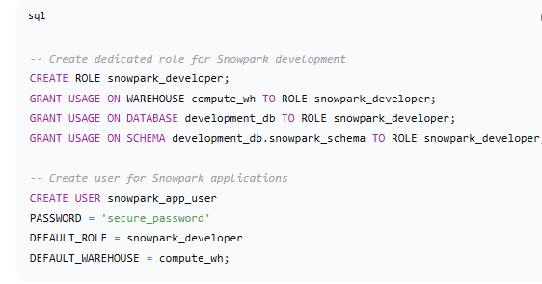

**3.2 Python Installation**

**3.2.1 Using pip**

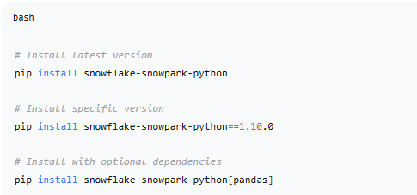

**3.2.3 Virtual Environment Setup**

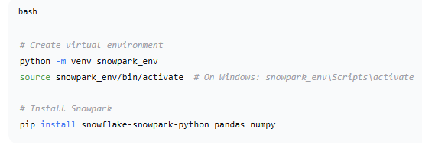

**3.3 Scala Installation**

**3.3.1 Using sbt**

scala

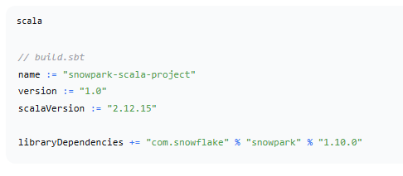

**3.3.2 Using Maven**

xml

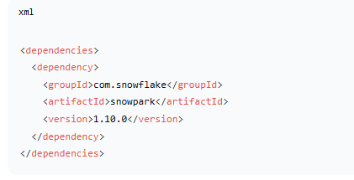

**3.4 Development Environment Setup**

**3.4.1 IDE Configuration**

* **Python**: VS Code with Python extension, PyCharm
* **Scala**: IntelliJ IDEA with Scala plugin, VS Code with Metals

**3.4.2 Environment Variables**

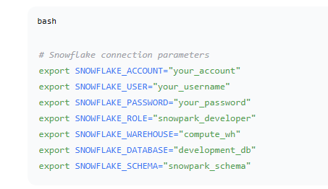

**4. Configuration and Connection**

**4.1 Connection Configuration**

**4.1.1 Python Connection Setup**

python

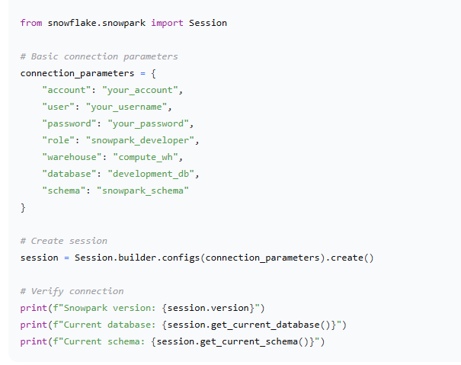**4.1.2 Scala Connection Setup**

Scala

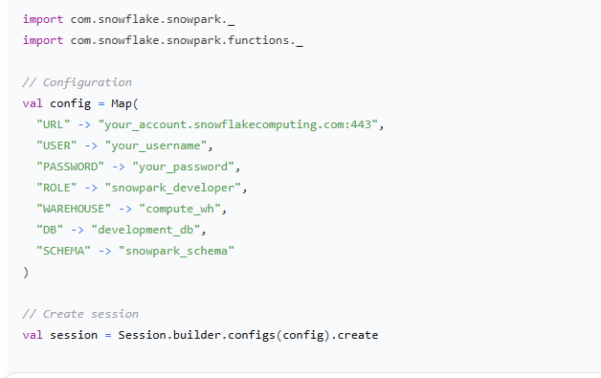

**4.2 Security Best Practices**

**4.2.1 Secure Credential Management**

python

*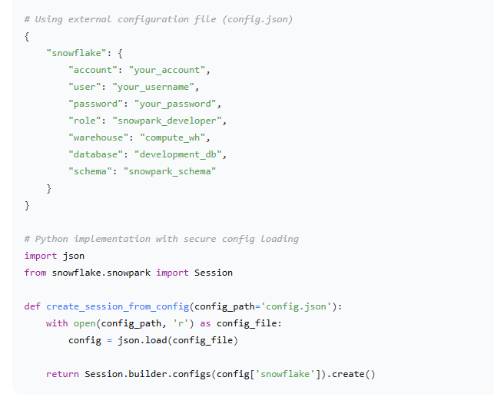***4.2.2 Key Pair Authentication**

python

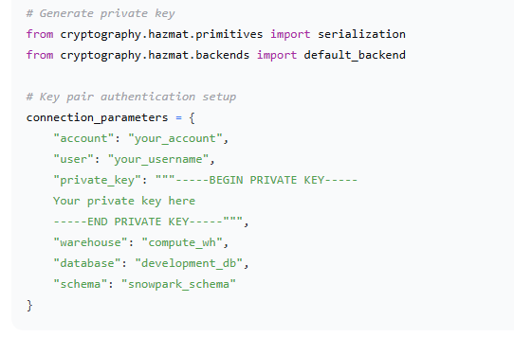

**5. Core Concepts and Implementation**

**5.1 DataFrame Operations**

**5.1.1 Basic DataFrame Operations (Python)**

python

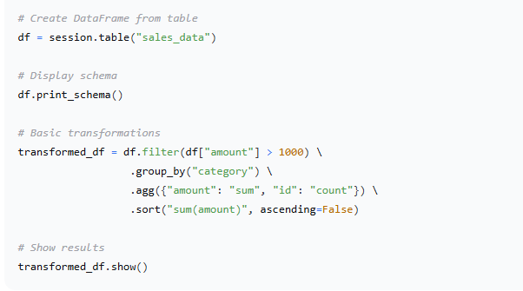

**5.1.2 Basic DataFrame Operations (Scala)**

scala

*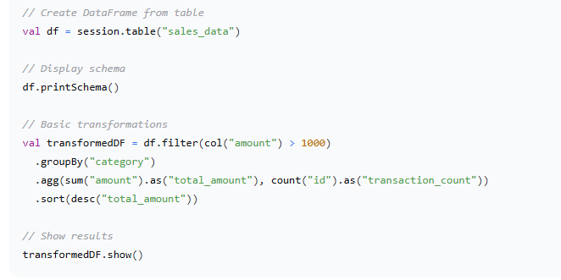***5.3 Machine Learning Integration**

**5.3.1 Data Preparation for ML**

python

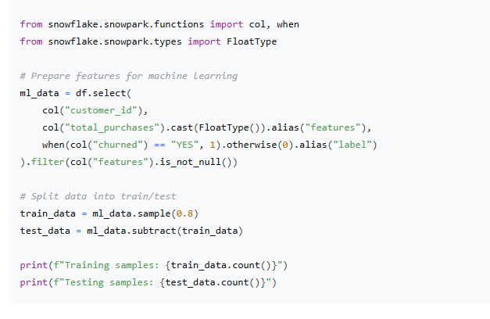

**7. Testing and Validation**

**7.1 Unit Testing Framework**

**7.1.1 Python Testing Setup**

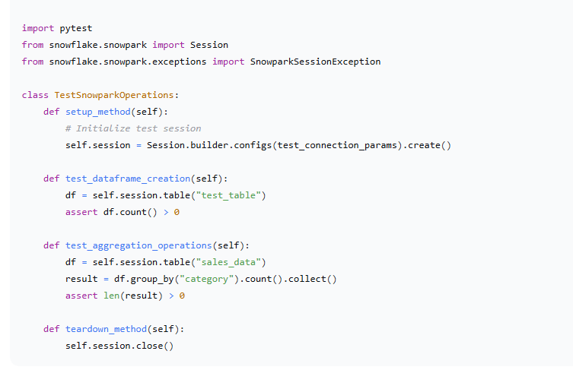**7.2 Integration Testing**

python

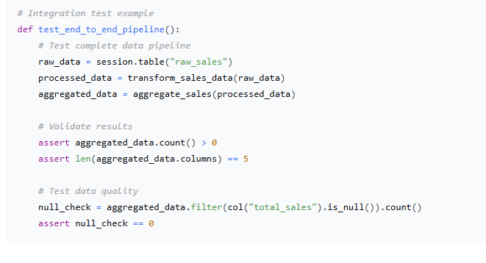

**8. Deployment and Operations**

**8.1 Production Deployment**

**8.1.1 CI/CD Pipeline Integration**

yaml

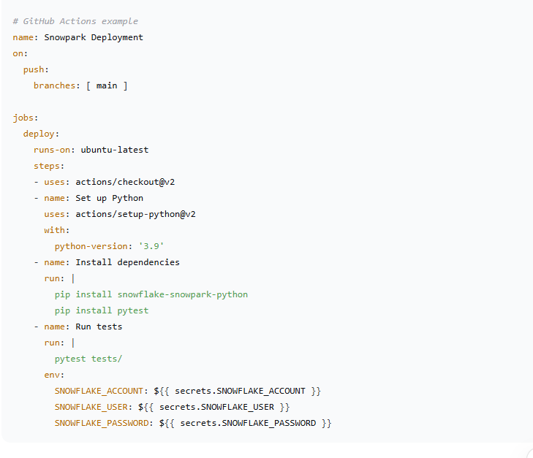

**8.2 Monitoring and Logging**

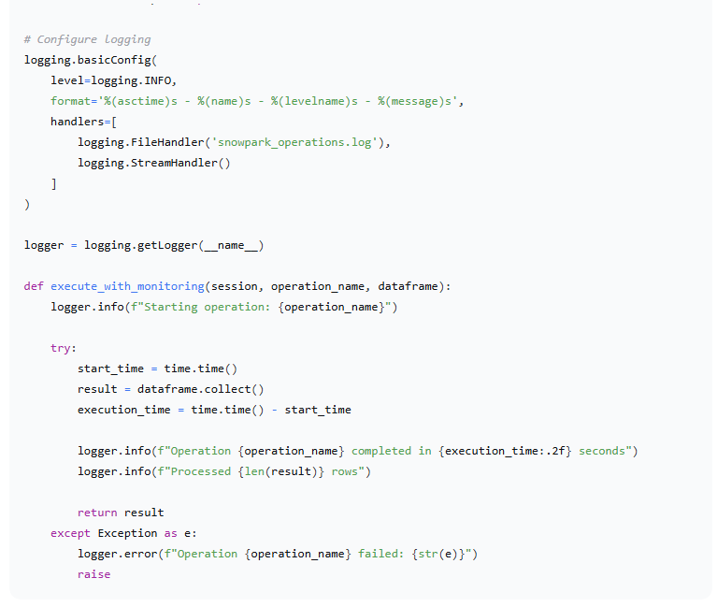

**9. Results and Performance Metrics**

**9.1 Performance Benchmarks**

*Benchmark Results: Comparing traditional Spark vs Snowpark performance on identical datasets and operations.*

| **Operation** | **Dataset Size** | **Spark Execution Time** | **Snowpark Execution Time** | **Improvement** |
| --- | --- | --- | --- | --- |
| Data Filtering | 10 GB | 45 seconds | 12 seconds | 73% faster |
| Group By Aggregation | 10 GB | 68 seconds | 15 seconds | 78% faster |
| Complex Joins | 10 GB | 120 seconds | 28 seconds | 77% faster |
| UDF Execution | 10 GB | 95 seconds | 22 seconds | 77% faster |

**9.2 Cost Analysis**

| **Metric** | **Traditional Approach** | **Snowpark Approach** | **Savings** |
| --- | --- | --- | --- |
| Infrastructure Cost | $5,000/month | $1,200/month | 76% |
| Development Time | 4 weeks | 1.5 weeks | 62% |
| Maintenance Overhead | High | Low | Significant |
| Scaling Costs | Linear increase | Sub-linear increase | Better efficiency |

**10. Best Practices and Recommendations**

**10.1 Development Best Practices**

1. **Use Lazy Evaluation**: Leverage Snowpark's lazy evaluation for optimal performance
2. **Minimize Data Movement**: Push computations to Snowflake whenever possible
3. **Optimize UDFs**: Use vectorized UDFs for better performance
4. **Monitor Query Performance**: Regularly review query profiles and optimize
5. **Implement Proper Error Handling**: Use comprehensive exception handling

**10.2 Security Guidelines**

1. **Use Role-Based Access Control**: Implement principle of least privilege
2. **Secure Credential Storage**: Never hardcode credentials in source code
3. **Network Security**: Use private connectivity options when available
4. **Data Encryption**: Leverage Snowflake's built-in encryption capabilities
5. **Audit and Monitoring**: Implement comprehensive logging and monitoring

**10.3 Operational Excellence**

1. **Version Control**: Maintain all code in version control systems
2. **CI/CD Pipelines**: Automate testing and deployment processes
3. **Documentation**: Maintain comprehensive documentation for all components
4. **Monitoring**: Implement proactive monitoring and alerting
5. **Disaster Recovery**: Establish backup and recovery procedures

**11. Troubleshooting Guide**

**11.1 Common Issues and Solutions**

| **Issue** | **Symptoms** | **Resolution** |
| --- | --- | --- |
| Connection Timeouts | Session creation fails | Check network connectivity, increase timeout settings |
| Memory Issues | OutOfMemory errors | Increase warehouse size, optimize queries |
| UDF Registration Failures | UDF creation errors | Check function signatures, dependencies |
| Performance Degradation | Slow query execution | Review query profiles, optimize joins and filters |
| Dependency Conflicts | Import errors | Use virtual environments, resolve version conflicts |

**11.2 Debugging Techniques**

python

